Course Four

Regression Analysis: Simplifying Complex Data Relationships
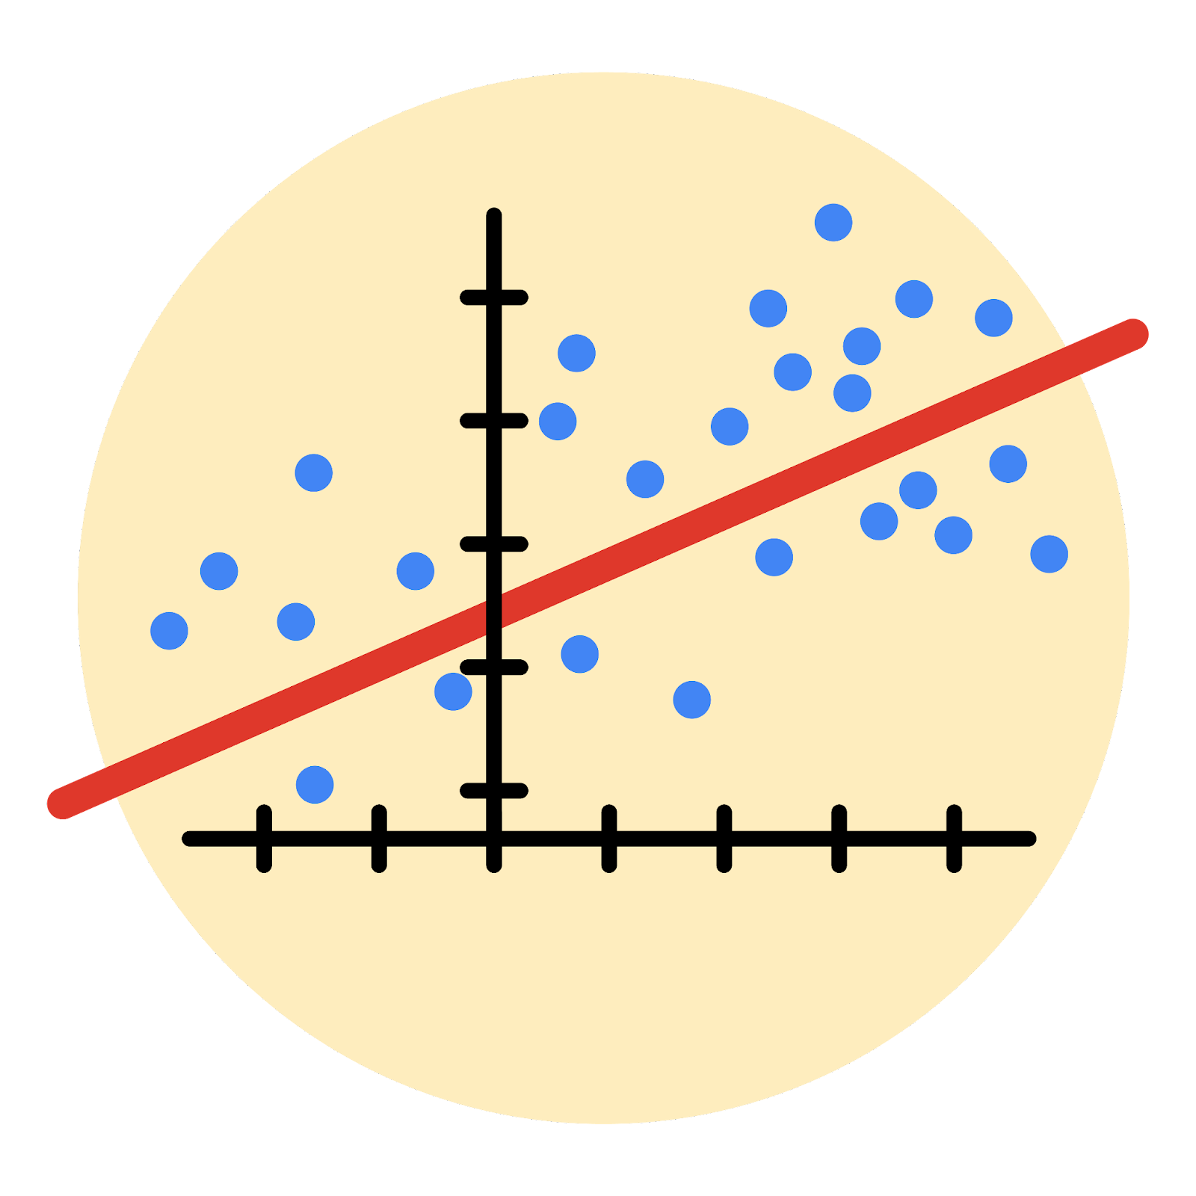

Instructions
Use this PACE strategy document to record decisions and reflections as you work through this end-of-course project. As a reminder, this document is a resource that you can reference in the future, and a guide to help you consider responses and reflections posed at various points throughout projects.

Course Project Recap
Regardless of which track you have chosen to complete, your goals for this project are:
- Complete the questions in the Course 4 PACE strategy document
- Answer the questions in the Jupyter notebook project file
- Build a multiple linear regression model
- Evaluate the model
- Create an executive summary for team members

Relevant Interview Questions
Completing the end-of-course project will empower you to respond to the following interview topics:
- Describe the steps you would take to run a regression-based analysis
- List and describe the critical assumptions of linear regression
- What is the primary difference between R² and adjusted R²?
- How do you interpret a Q-Q plot in a linear regression model?
- What is the bias-variance tradeoff? How does it relate to building a multiple linear regression model? Consider variable selection and adjusted R².
Reference Guide
This project has seven tasks; the visual below identifies how the stages of PACE are incorporated across those tasks.
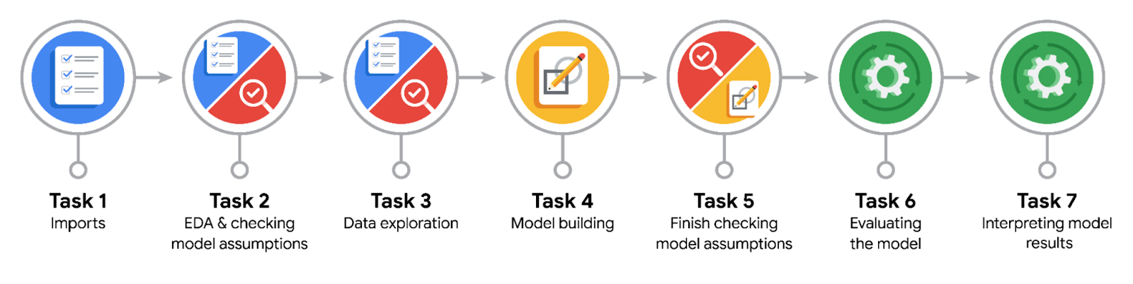

Data Project Questions & Considerations
PACE: Plan Stage
- Who are your external stakeholders for this project?
TikTok users and content creators who want a classification of the content they are interacting with.

- What are you trying to solve or accomplish?
Build and evaluate a logistic regression model to predict a user’s verified_status based on video characteristics, which can be combined with future models to generate a prediction of claim_status for videos.

- What are your initial observations when you explore the data?
  - 298 rows with null values in 7 columns
  - Imbalance in unverified and verified accounts percentage (93.71% & 6.29%)
  - Different average video transcription length for claims and opinions videos (95.34 and 82.45)
  - High correlation between 5 counter metrics

- What resources do you find yourself using as you complete this stage?
  - pandas and NumPy for data manipulation, seaborn for visualizations of value distribution and variable correlation, and resample from sklearn.utils to balance the number of samples from unverified and verified accounts
  - The PACE strategy document and the Jupyter Notebook

PACE: Analyze Stage
- What are some purposes of EDA before constructing a multiple linear regression model?
  - The independent variables for a linear regression model must satisfy the conditions of linearity with dependent variable, come from independent observations, and have no multicollinearity between any 2 of them, which requires EDA to create and select the appropriate variables.
  - Handle outliers or null values in those variables
  - Perform one-hot encoding for categorical independent variables
- Do you have any ethical considerations at this stage?
Besides data representation imbalance and handling outliers, there could be historical bias in the independent features based on TikTok’s past policy, and potential misclassifications of a user’s verified status that can affect the future claims classification model.

PACE: Construct Stage
- Do you notice anything odd?
There is an imbalance in the independent variables such as claim_status and author_ban_status, which can lead to inherent bias in the logistic regression model.

- Can you improve it? Is there anything you would change about the model?
Perhaps it would be better to resample the verified and unverified user data in such a way that somewhat reflects the rates of verified users, active users, and claim status in the dataset, instead of resampling for just the dependent variable.

- What resources do you find yourself using as you complete this stage?
  - train_test_split from sklearn.model_selection
  - OneHotEncoder from sklearn.preprocessing
  - LogisticRegression from sklearn.linear_model
  - pandas to verify the changes in the train data

PACE: Execute Stage
- What key insights emerged from your model(s)?
The model predicted a lot of false positives, which can be expected since the original dataset has a majority of data from unverified users, which affected the precision score at 60.6% and the accuracy at 64.9%. Nevertheless, there are relatively few predicted false negatives, probably because the model studied each record from verified users multiple times during its training, thus the model got an 84.6% recall score.

- To interpret model results, why is it important to interpret the beta coefficients?
The beta coefficients represent how changes in an independent variable affect the dependent variable, in this case the dependent variable is affected exponentially by the independent variable.

- What potential recommendations would you make?
Variables such as transcription length and engagement metrics can also be excellent indicators of a video’s claim status, which can be used in future models.

- Do you think your model could be improved? Why or why not? How?
The relatively low precision and accuracy score suggest the usage of more advanced models such as tree-based learning algorithms to predict the claim status of a video with higher scores in all 4 evaluation metrics.

- What business/organizational recommendations would you propose based on the models built?
From the model coefficients, it seems that a higher video duration indicates the likelihood of the video coming from a verified user, while videos with higher view counts is more likely to come from an unverified user. Both trends can be further investigated by TikTok’s product and algorithmic ranking team.

- Given what you know about the data and the models you were using, what other questions could you address for the team?
  - Textual analysis of the video_transcription_text to differentiate claims & opinions
  - Analyse the high number of false positives to determine properties of videos from these unverified accounts that is similar to videos from verified accounts.

- Do you have any ethical considerations at this stage?
  - Transparency of model limitations
  - If a higher view count suggests an unverified user’s video, then it punishes legitimate users whose videos happen to go viral
  - The model should not be used for other purposes than predicting claim status

